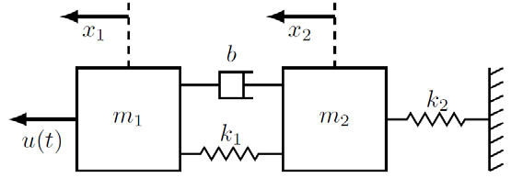
Task#1:

Differential Equation:
$$mẍ = u(t) - bẋ - kx$$

System:
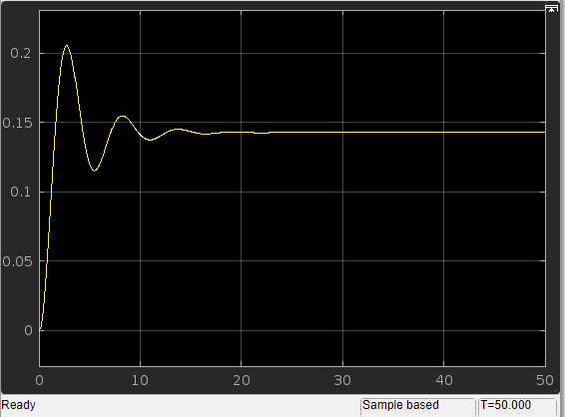
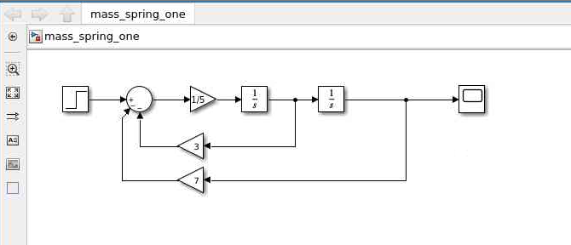
Task 2
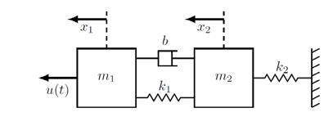
Differential equation:
$$m_{2}{\ddot{x}}_{2}=-k_{2}x_{2}+k_{1}\left(x_{1}-x_{2}\right)+b({\dot{x}}_{1}-\dot{x_{2}})$$
$$m_{1}{\ddot{x}}_{1}=-k_{1}\left(x_{1}-x_{2}\right)-b\left({\dot{x}}_{1}-{\dot{x}}_{2}\right)+u\left(t\right)$$

System:
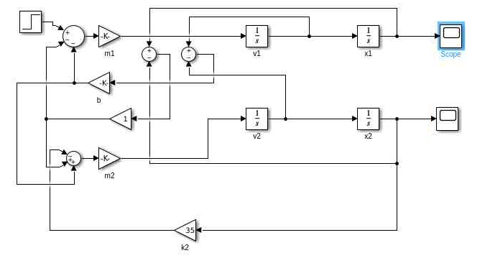

X1:
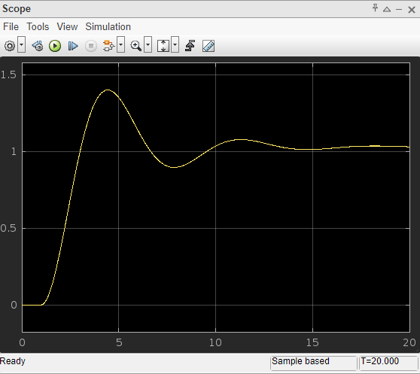
X2:
